**FIND THE MOST STRATEGIC**

**PLACE FOR YOUR RESTAURANT IN BALI**

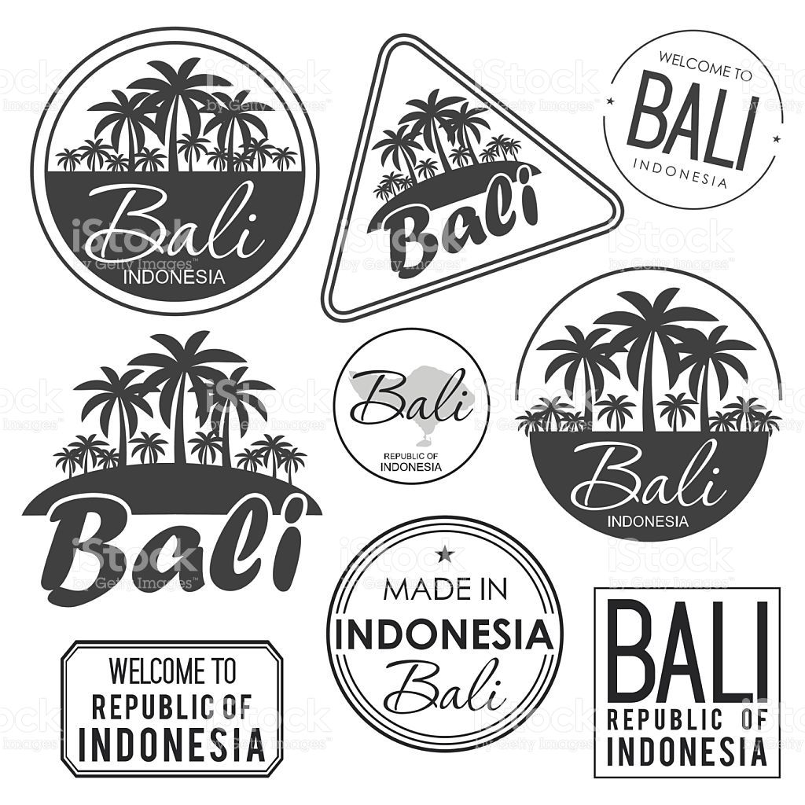

**Sebastian Cahyo Ardhi Iswara**

[https://www.linkedin.com/in/*cahyoardhi*/](https://www.linkedin.com/in/cahyoardhi/)

**TABLE OF CONTENT**

**1.** **INTRODUCTION** 3

**1.1** **Background** 3

**1.2** **Problem** 3

**2.** **DATA** 3

**2.1** **Source** 3

**2.2** **Preprocessing** 4

**3.** **METHODOLOGY** 4

**4.** **RESULT** 7

**5.** **DISCUSSION** 8

**6.** **CONCLUSION** 8

# **INTRODUCTION**

## **Background**

Bali, bali is an island that people commonly know as paradise. Culture, food, tourist attractions are things that make people competing to come and enjoy themselves in Bali.

Island that located in the Indonesian archipelago has a lot of charm that makes many people go to visit Bali every year. Besakih Temple, Kuta Beach, Ubud monkey forest are just a few examples of places frequently visited by travelers from various countries.

In addition to its attractive natural charm, culinary in Bali also has its own allure for its fans, Babi Guling Bu Oka in Ubud, ayam betutu men tempeh in gilimanuk, nasi campur Bu Oki in Nusa Dua are some examples of locations that offer authentic Balinese cuisine and commonly loved by the local community and tourists

## **Problem**

because Bali is often the target by tourists and has many interesting things, frequently there are people who want to open a business on this island. One of the businesses that sell well in Bali is food business, but due to the large number of business operators in Bali, competition to sell products has become a difficulty.

In this era, more and more data is generated intentionally or unintentionally and if we process the data properly we can produce an insight that can help us to solve a problem, if there is someone who wants to open a culinary business in Bali, and that person does not do the analysis and has no business experience, it is likely that the business will fail and of course will harm the financial of that person.

Therefore it would be better if before doing business, we analyze the existing problems and look for insight into these problems, One way to avoid the risk of failing to do business, is consult to data scientists who have the knowledge needed to understand the existing problems.

# **DATA**

## **Source**

to be able understand and solve existing problems, a Data Scientist needs a quality good dataset and creativity so that the problem can be resolved, here are some data sources that used in this problem:

1. List of regency in Bali by Wikipedia

<https://id.wikipedia.org/wiki/Daftar_kabupaten_dan_kota_di_Bali>

this data is crawled with bs4 and request module, then cleansed and created some new feature to support us make a good understanding

1. List of worker and company in by Bali Statistics Agency

<https://bali.bps.go.id/statictable/2019/10/09/161/jumlah-perusahaan-dan-tenaga-kerja-industri-besar-dan-sedang-menurut-kabupaten-kota-di-bali-2018.html>

the data is downloaded from website, then cleansed and created some new feature to support us make a good understanding

1. Foursquare API to find any recommended restaurant

From Denpasar coordinate, we search recommendation place in Denpasar and cleansed, create new feature to support us make a good understanding about it

## **Preprocessing**

for preprocessing, I decided to use pandas, feature engineering is helped by geopy coordinate finder and foursquare API

# **METHODOLOGY**

1. **Analysis Wikipedia data**

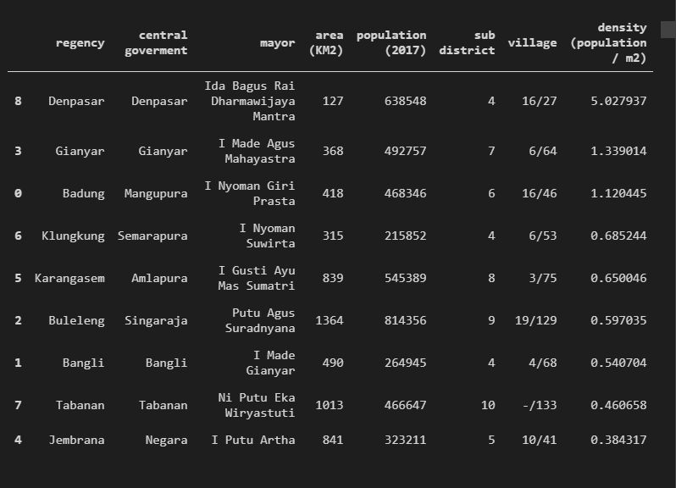

on Wikipedia data, we interested with population density in every regency, so after we visualize it, we get insight that the most dense regency is Denpasar, because Denpasar is the most dense regency, we decide to analysis more in Denpasar

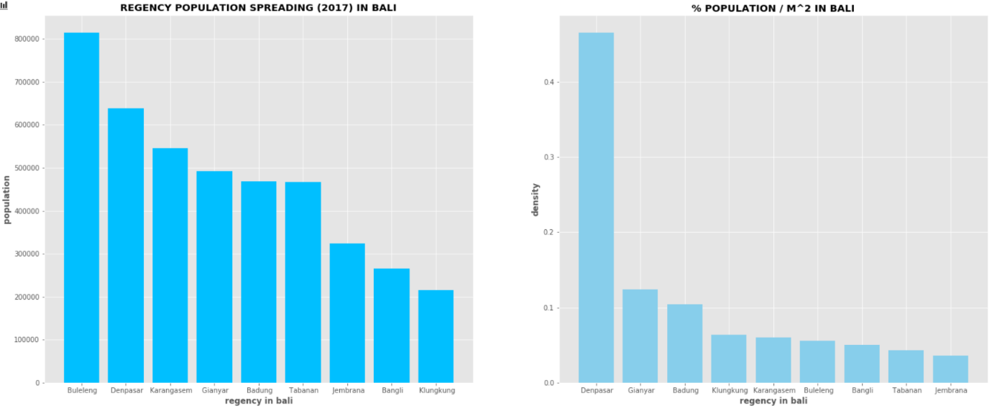

1. **Analysis Number Of Worker And Company In Every Regency By Bali Statistics Agency Data**

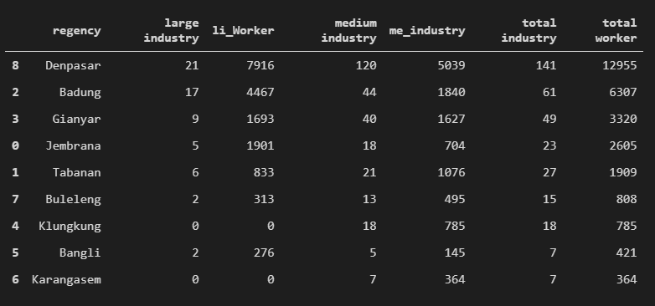

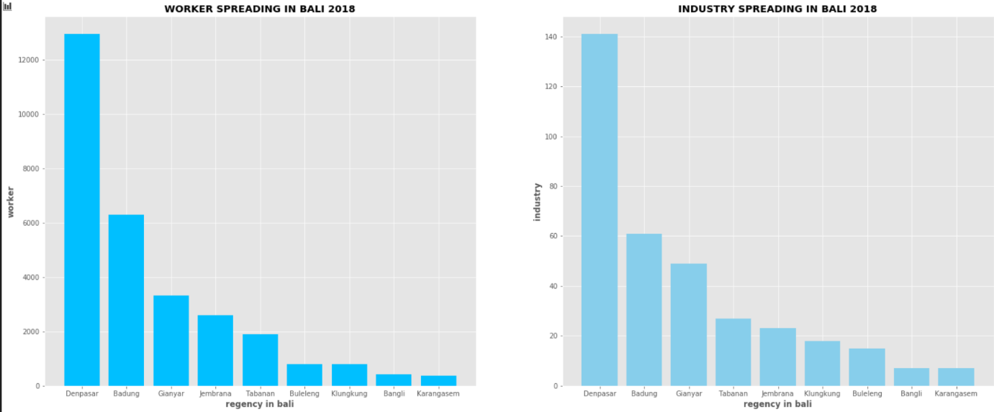in worker data, we interested what regency is most workers, so we decide to visualize it and sort the data decreasing

after we visualize our data, there are interesting pattern, Denpasar beside the most dense regency, most worker is work in Denpasar. Because this pattern, we decide to analysis more deeply into Denpasar

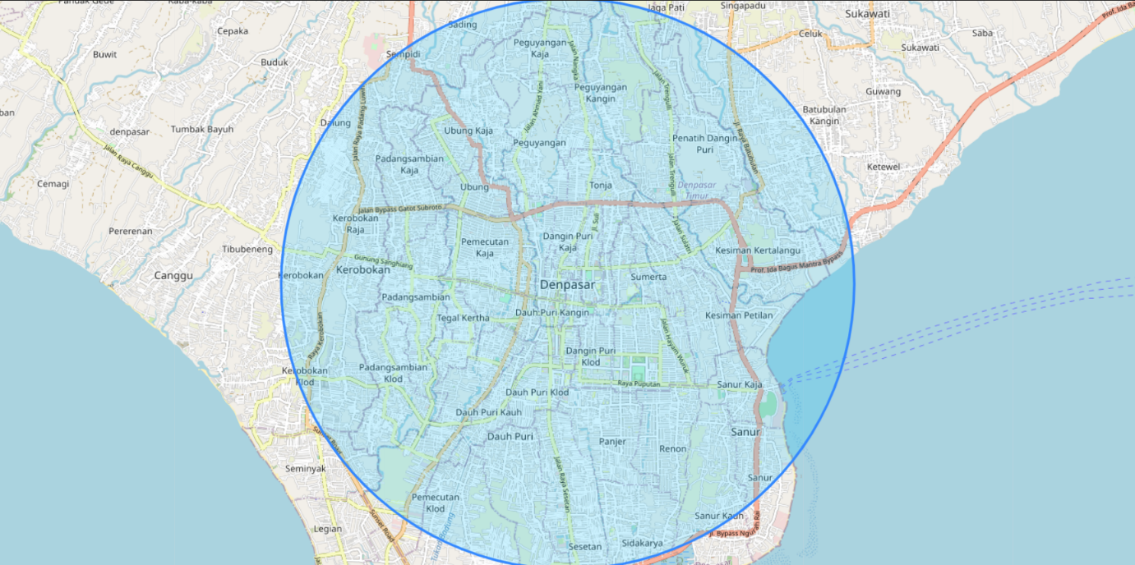

using geopy to find Denpasar coordinate, we visualize Denpasar area with folium so we know where is Denpasar in Bali

1. 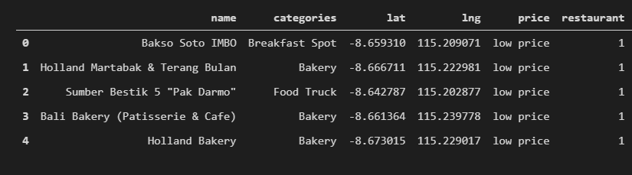 **Analysis Denpasar data from foursquare API**

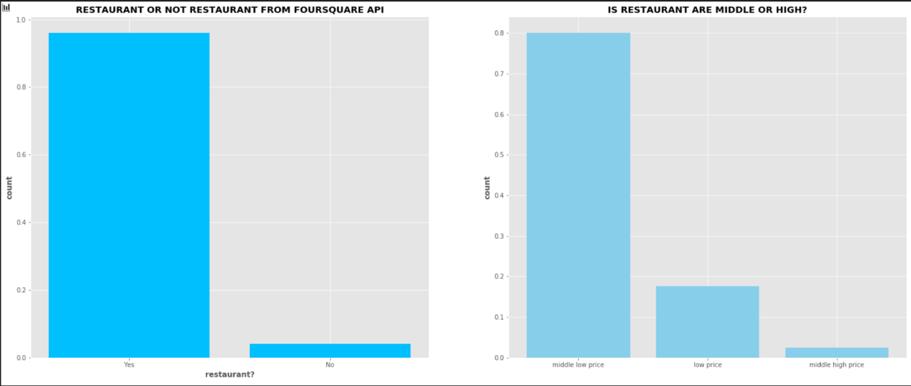The data that we get from foursquare API, show that most restaurant price point Is in medium low price section / 10$ - 20$ USD price point, with this data we can suggest our client to sell food price in 10$– 20$ USD

# **RESULT**

Using foursquare API data and geopy, to find the most strategic place for opening a restaurant business, there is the visualization of area (area inside the circle is recommended)

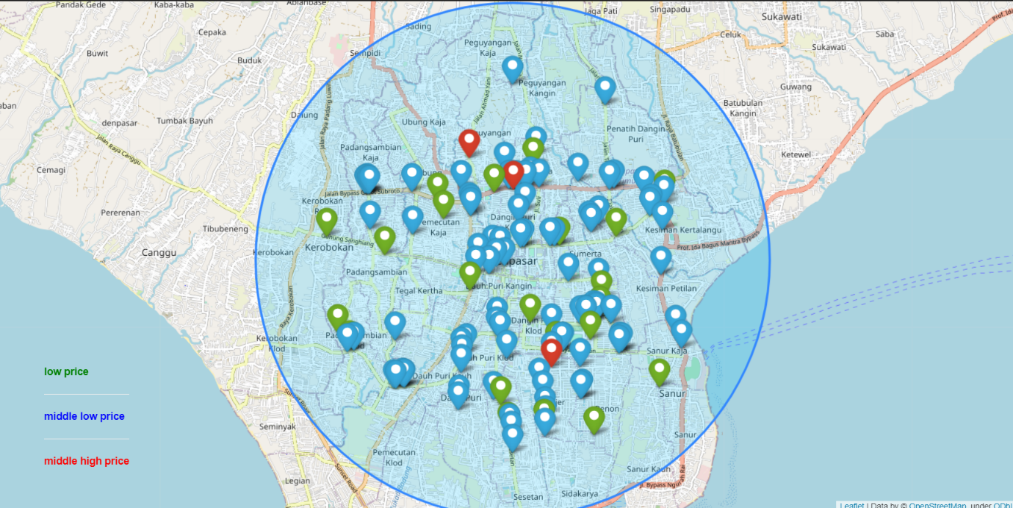

# **DISCUSSION**

After EDA, from our dataset, we can conclude that the strategic location to restaurant is Denpasar, Denpasar is close to the airport, have good population density, and safe place to build a business, the safest price range point for restaurant is ‘middle low price’ / 10$ - 20$ USD

# **CONCLUSION**

In the end, we got many insight from our dataset, there are:

1. Denpasar is the strategic place to run a business
2. Denpasar population and worker density is good for a business
3. Restaurant can be clustered into 3 cluster:
   1. Low Price < 10$ USD
   2. Middle Low Price 10$ - 20$USD
   3. Middle High Price >20$ USD
4. Most common restaurant cluster is Middle Low Price restaurant